1 a.

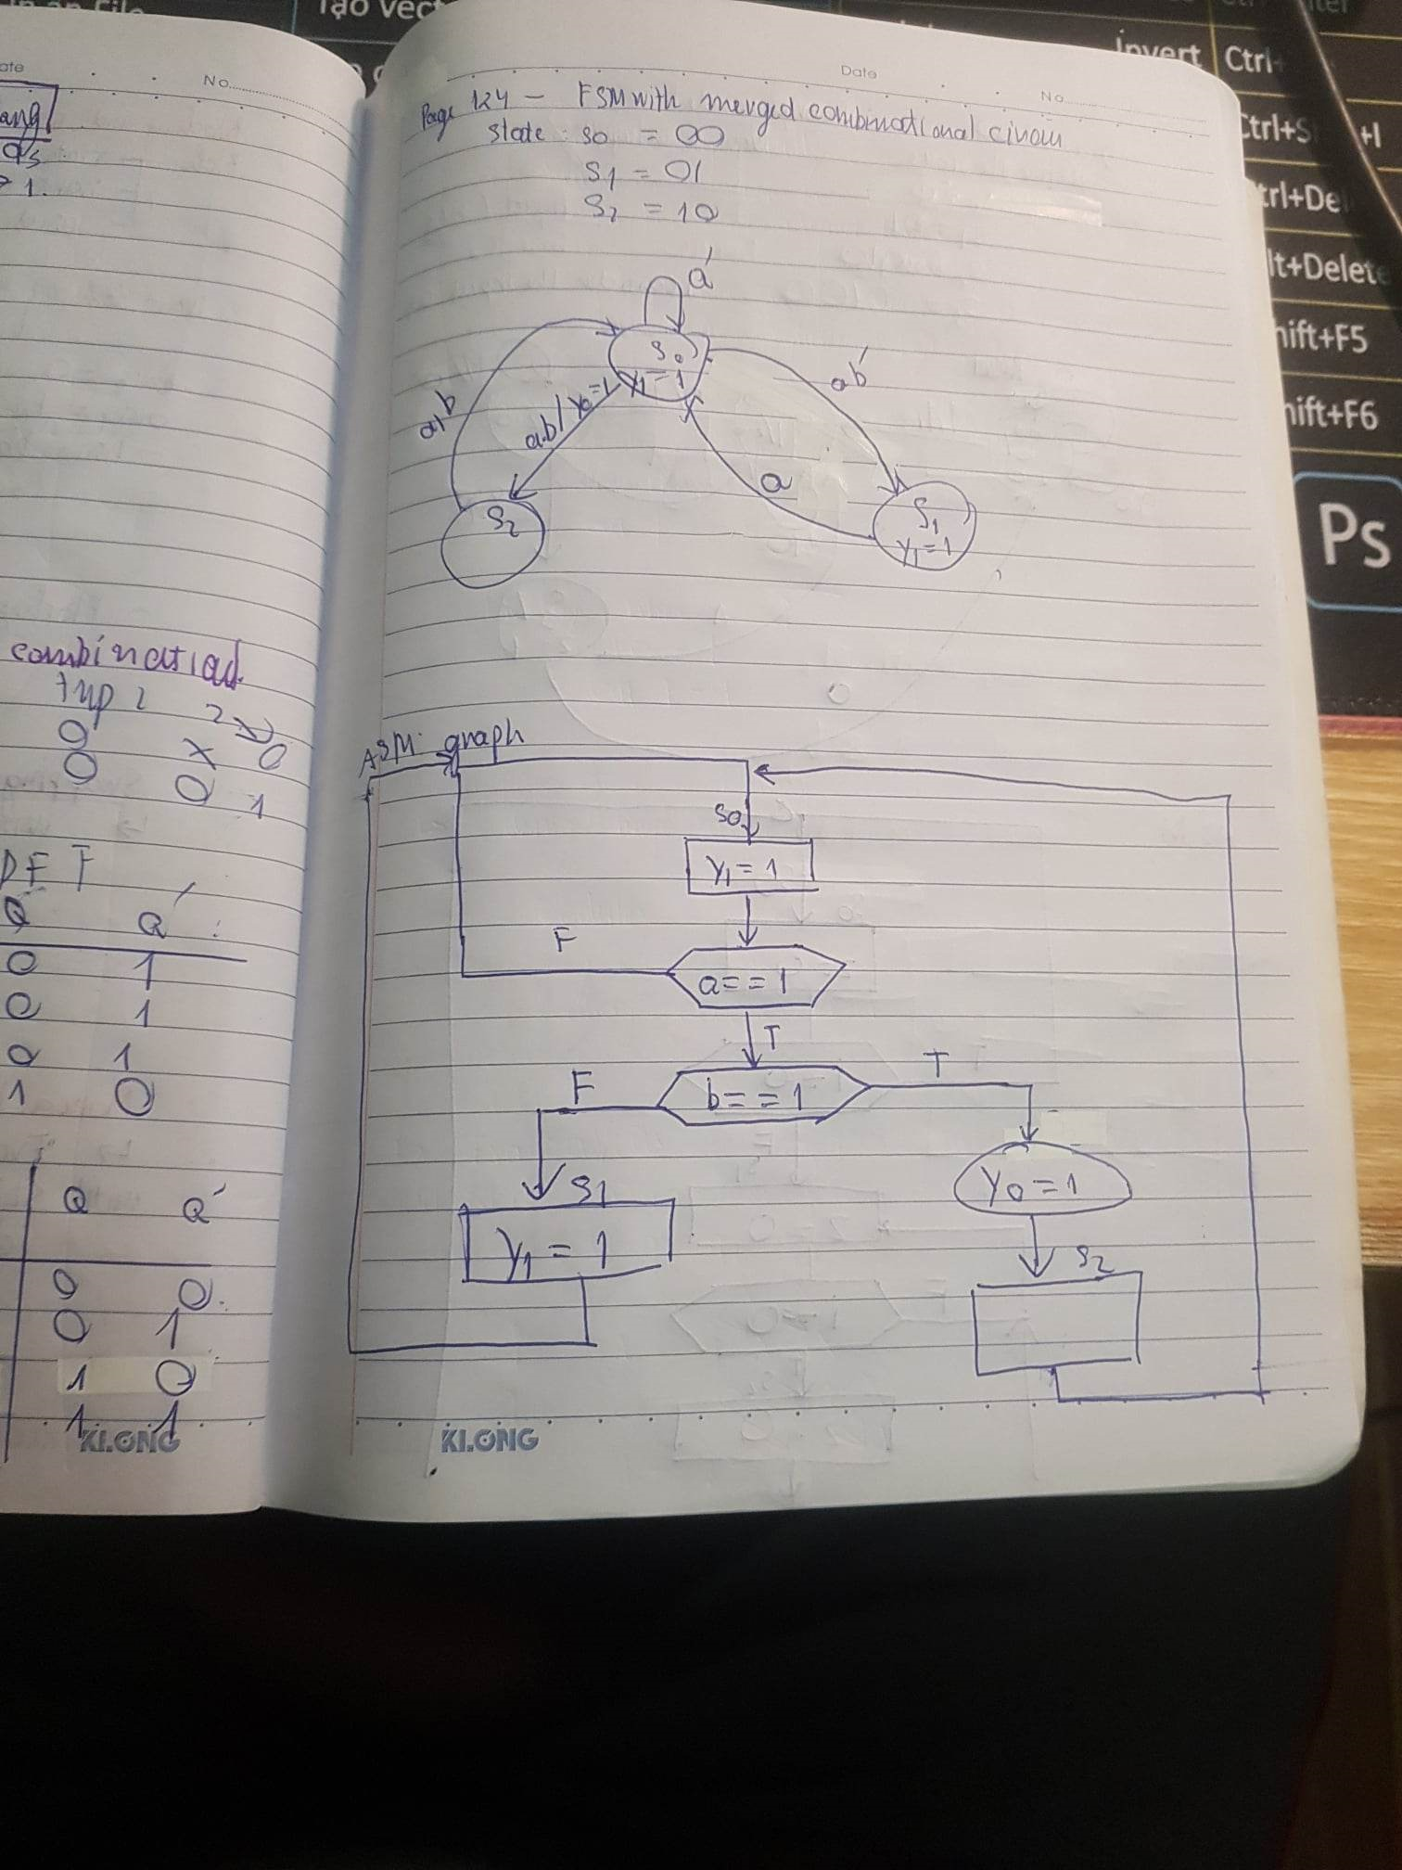

**Testbench**

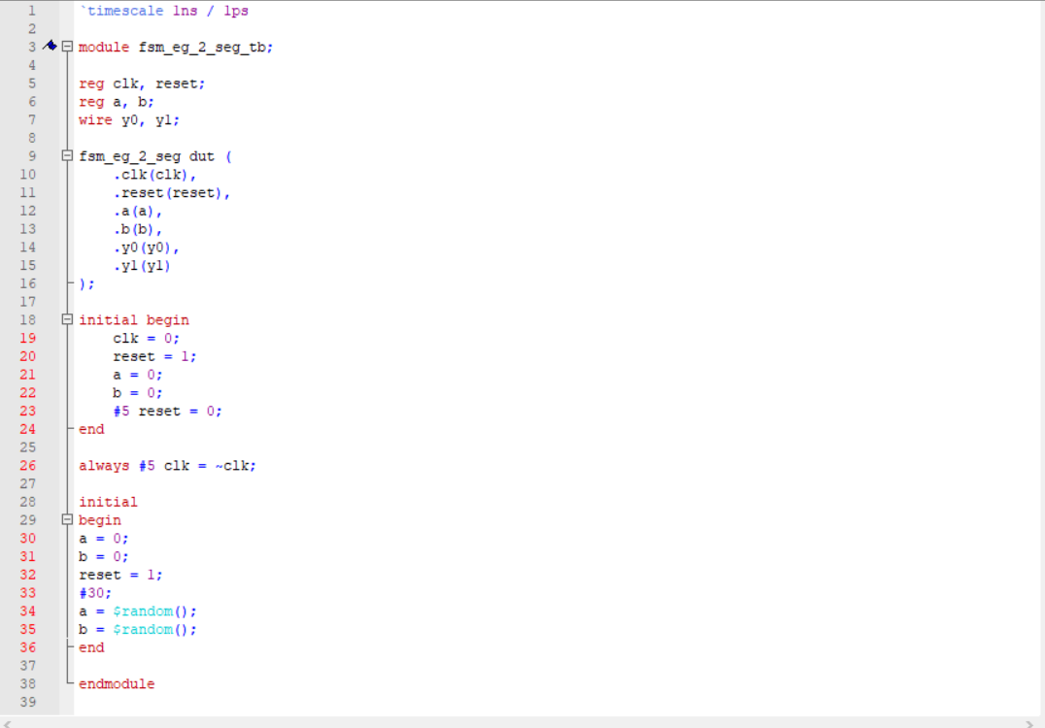

**Wave  
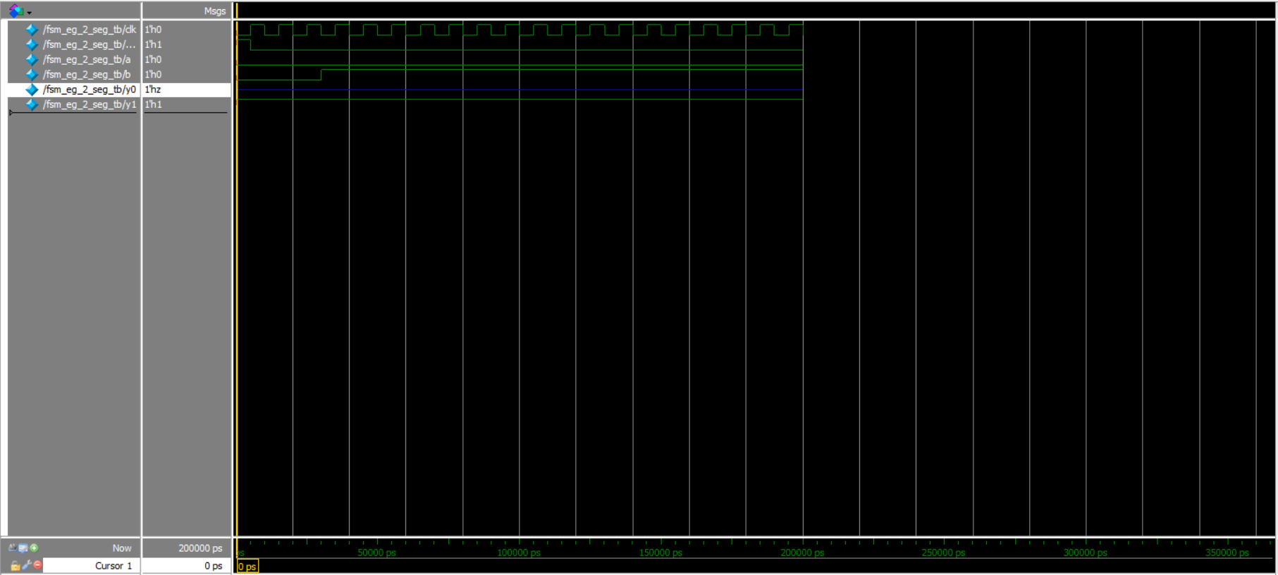**

**b.**

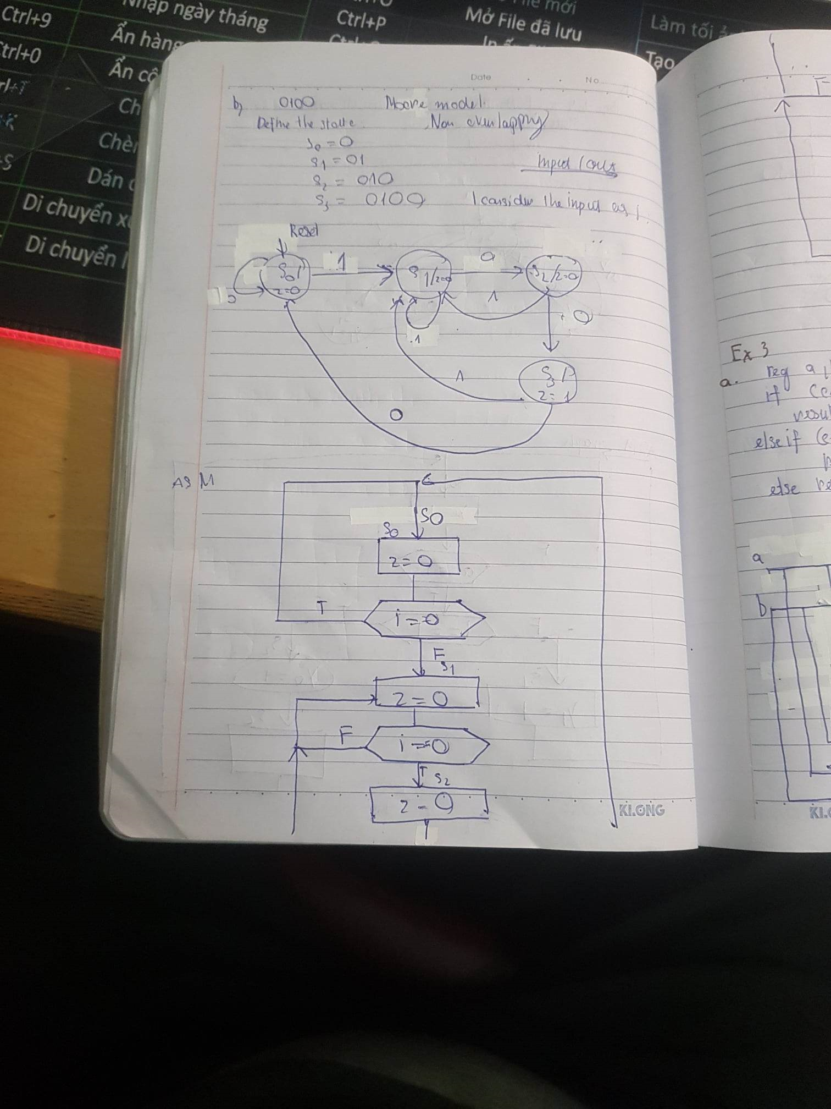

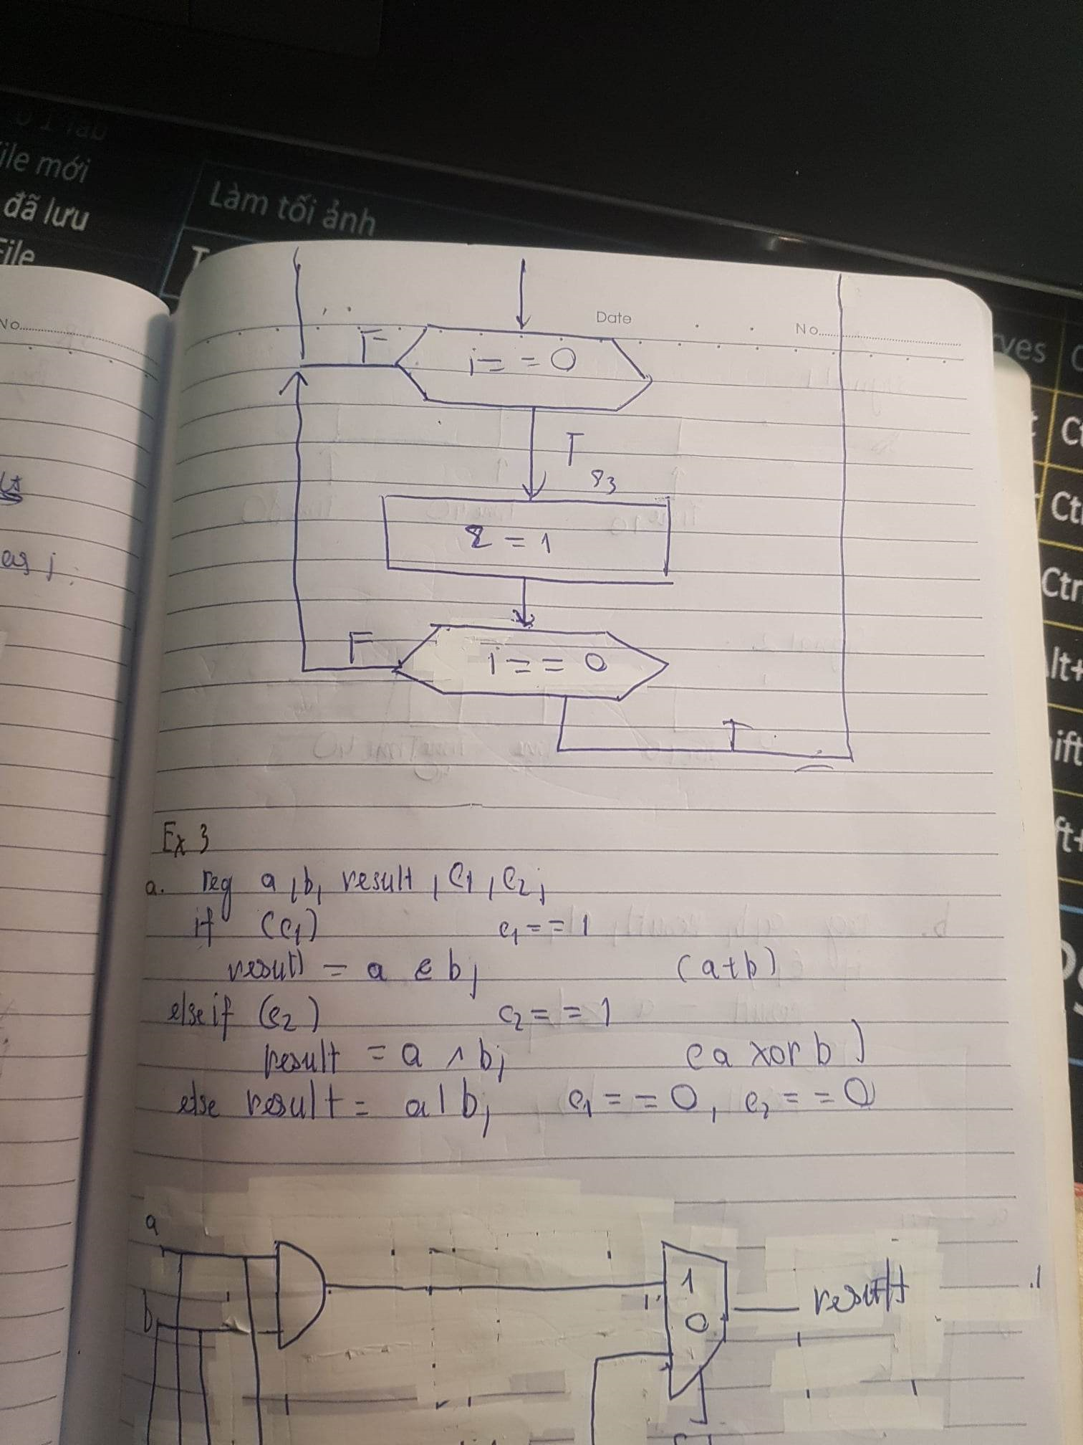

**RTL file**

module fsm2(

input wire clk, reset,

input wire a,

output y0

);

localparam [1:0] s0 = 2'b00,

s1 = 2'b01,

s2 = 2'b10,

s3 = 2'b11;

// signal declaration

reg [1 : 0] state_reg, state_next;

// state register

always @(posedge clk, posedge reset)

if (reset)

state_reg <= s0;

else state_reg <= state_next;

// next-state logic and output logic

always @*

case(state_reg)

s0:

if (a==1)

state_next = s1;

else

state_next = s0;

s1:

if(a == 1)

state_next =s2;

else

state_next = s1;

s2:

if(a == 0)

state_next = s3;

else

state_next = s1;

s3:

if ( a == 1)

state_next = s1;

else

state_next = s0;

endcase

assign y0 = (state_reg ==s3);

**endmodule**

**Testbench file**

`timescale 1ns / 1ps

module fsm2_tb;

reg clk, reset;

reg a;

wire y0;

fsm2 dut (

.clk(clk),

.reset(reset),

.a(a),

.y0(y0)

);

initial begin

clk = 0;

reset = 1;

a = 0;

#5 reset = 0;

end

always #5 clk = ~clk;

initial

begin

a = 0;

reset = 1;

#30;

a = $random();

end

endmodule

**Wave**

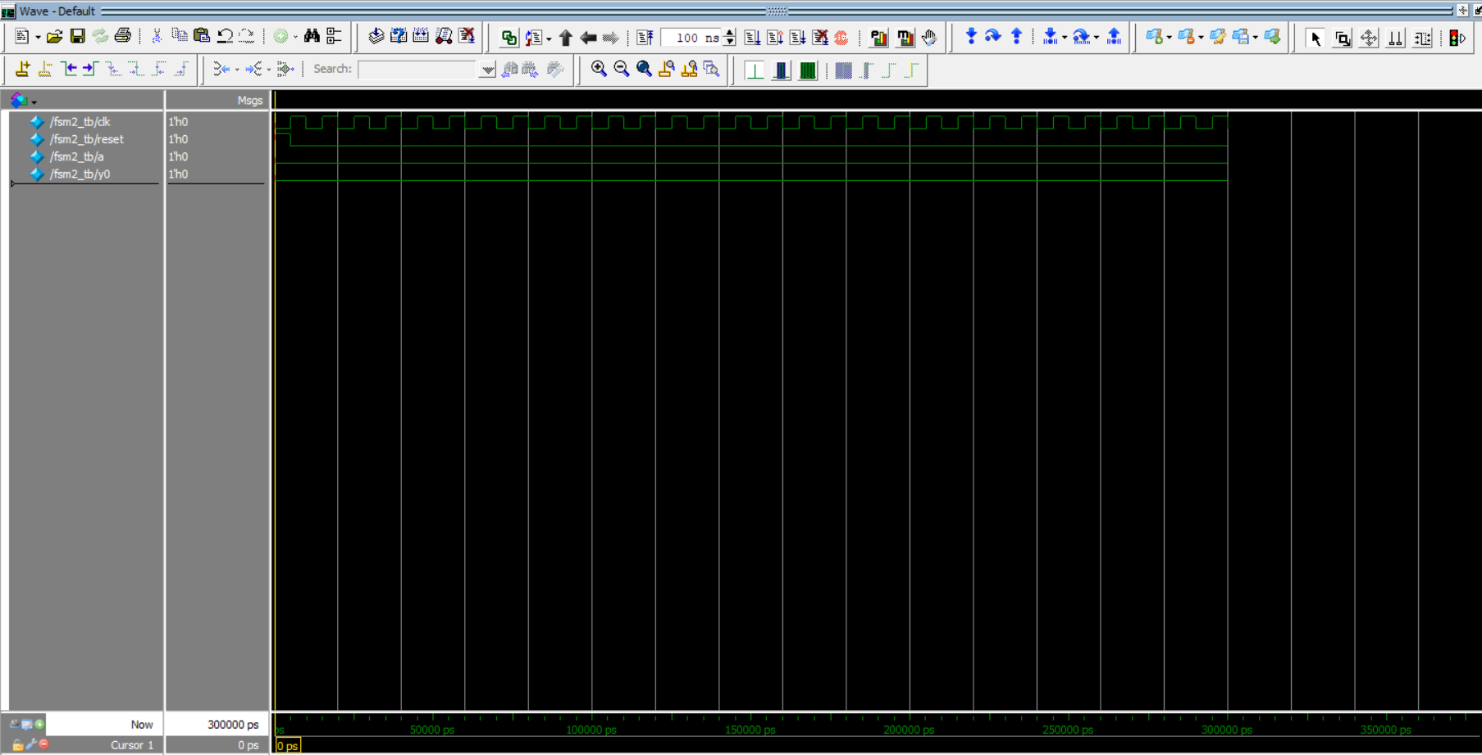

**Ex2**

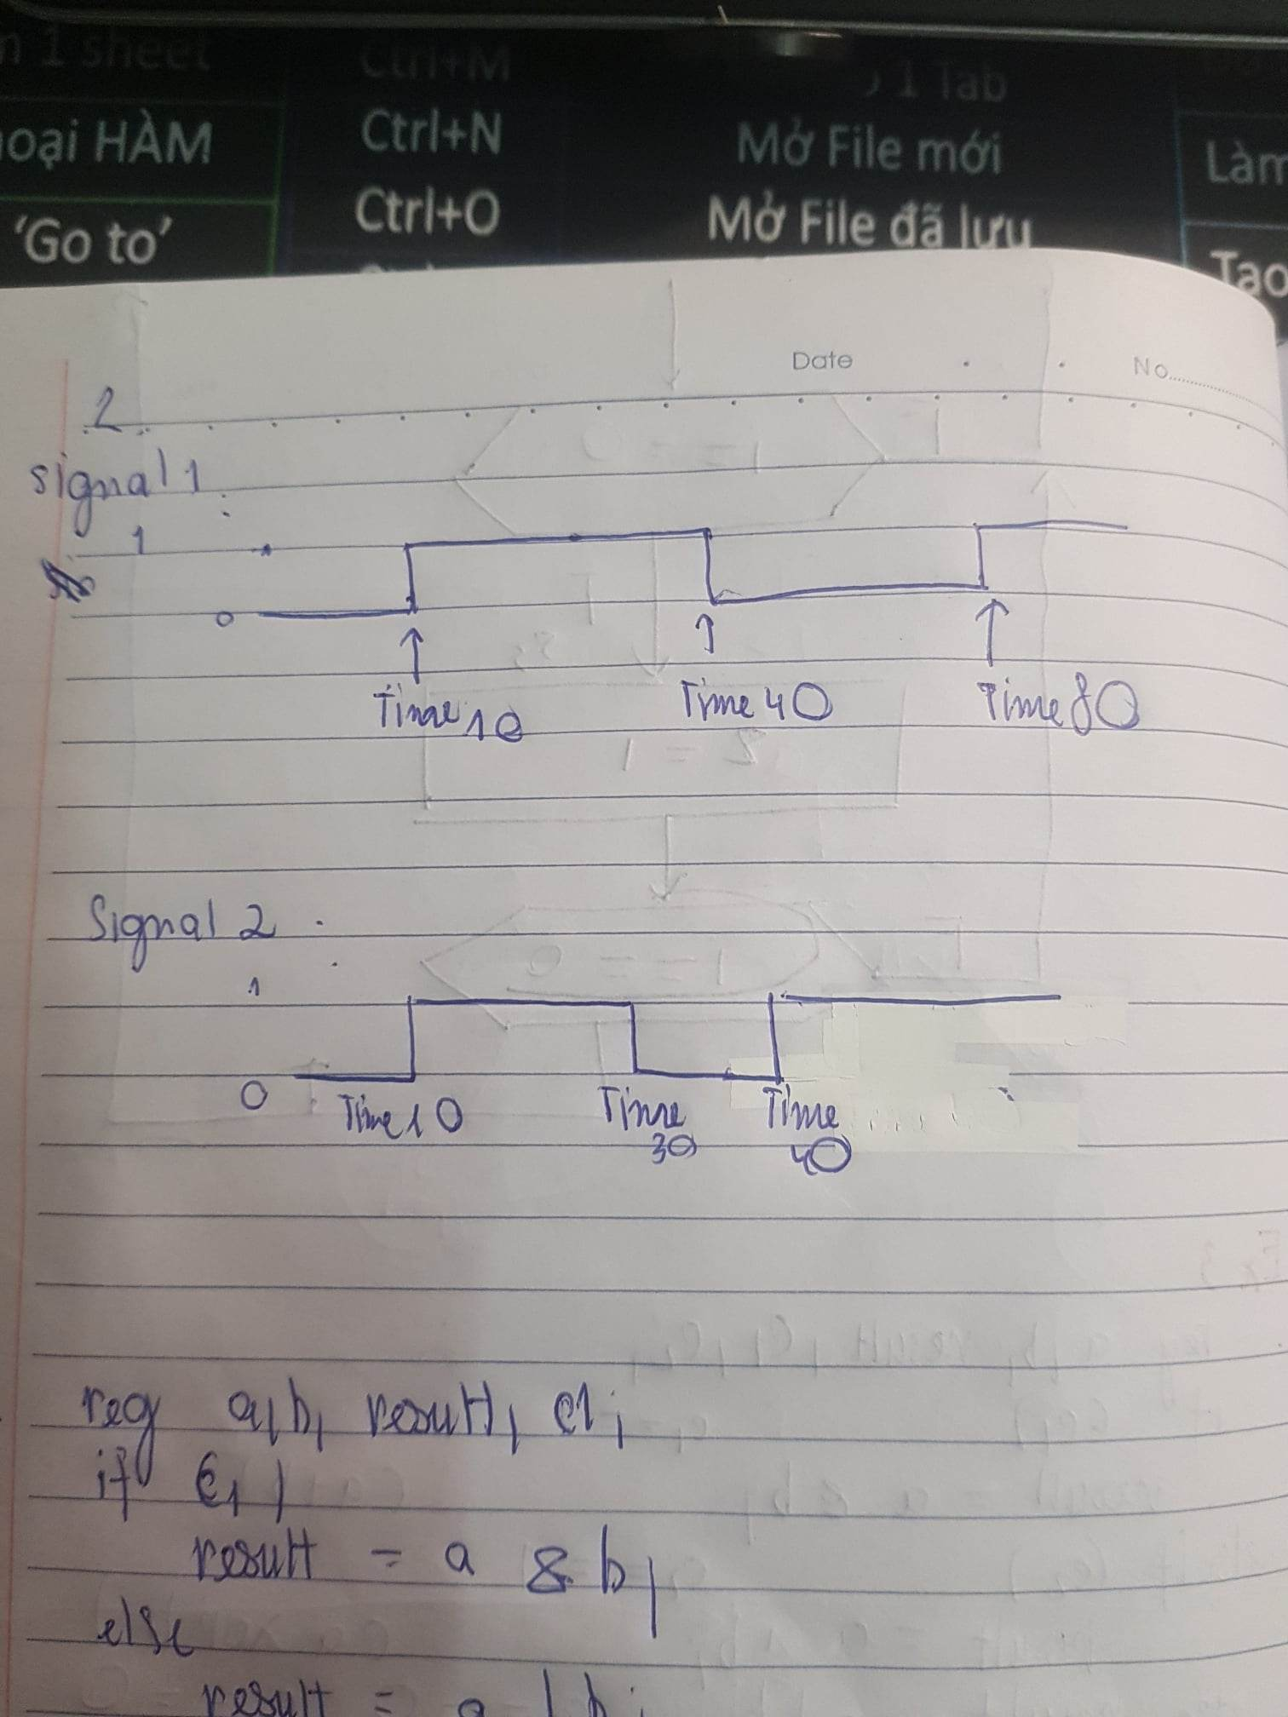

**Ex3**

